**INSTALLATION OF ANT(BUILD TOOL) & BUILDING ONE ANT PROJECT &DEPLOYING THAT WAR OR JAR OR EAR TO JFROG**

OUTPUT OF ANT IS : **BUILD.XML**

OUTPUT OF MAVEN IS : **POM.XML**

1. Take one linux system ,here I am taking amazon linux system
2. install java 8 by visiting this website

[**https://tecadmin.net/install-java-8-on-centos-rhel-and-fedora/**](https://tecadmin.net/install-java-8-on-centos-rhel-and-fedora/)

1. install jenkins software
2. install git software
3. Now install ant software

Ant is a build tool like maven

1. To install ant in your system paste the below command

wget <http://redrockdigimark.com/apachemirror//ant/binaries/apache-ant-1.10.1-bin.tar.gz>

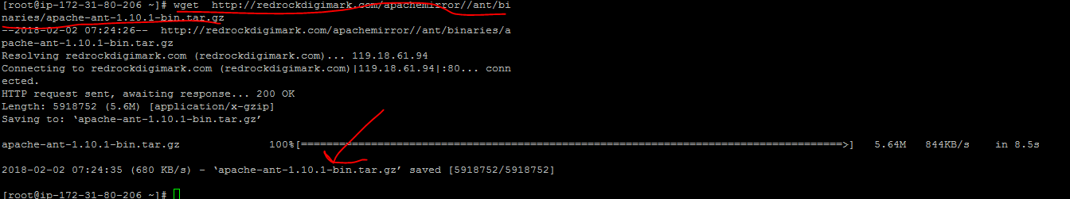

1. Now paste this command

**sudo tar xzf apache-ant-1.10.1-bin.tar.gz**



1. Now paste this command

**sudo ln -s apache-ant-1.10.1 ant**



1. Now paste this command

**sudo vi /etc/profile.d/ant.sh**



1. Now paste these two statements

export M2_HOME=/usr/local/ant

export PATH=${M2_HOME}/bin:${PATH}

Save and exit

1. Now run this command

**source /etc/profile.d/ant.sh**



**Ant home path is /usr/local/ant**

**Please set the ant path in jenkins 🡪manage jenkins 🡪 global tool configuration🡪select ant and keep the ant path**

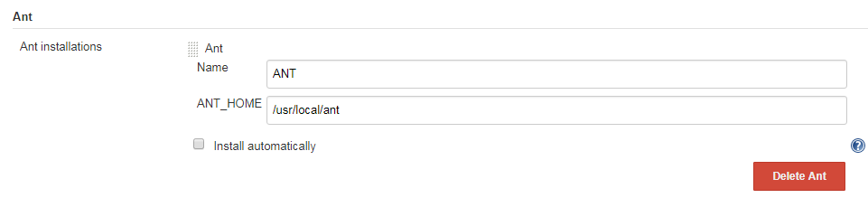

1. Now open jenkins select **free style project** keep any name for that project
2. In source code select git and paste the below ant sample url helloworld project

https://github.com/Silverpop/sample-helloworld-ant.git

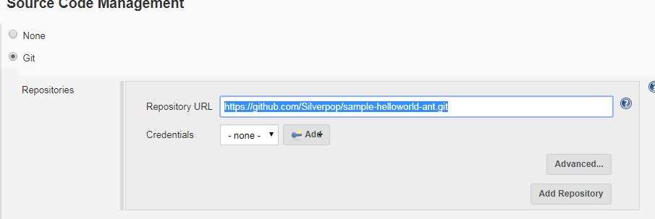

1. Now in build section u need to select **invoke ant** option then u will get this dialog box

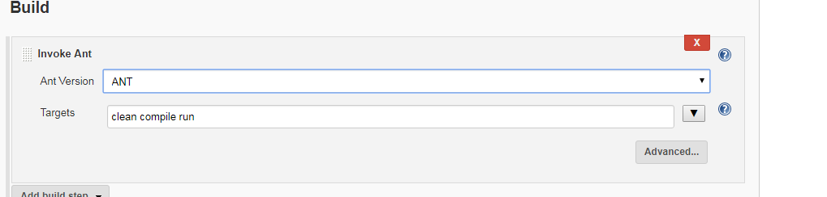

Select ant

In targets type clean compile run as mentioned above.

1. Now click on apply and save .Run the build

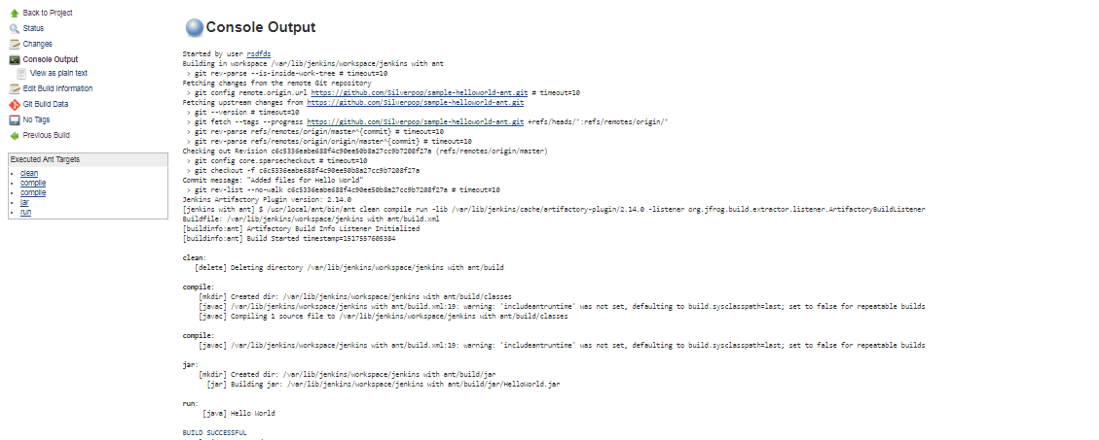

Guys it is success

1. Now take one more linux system, install java and jfrog in that system

Install artifactory plugin

In managejenkins🡪configure system🡪artifactory plugin

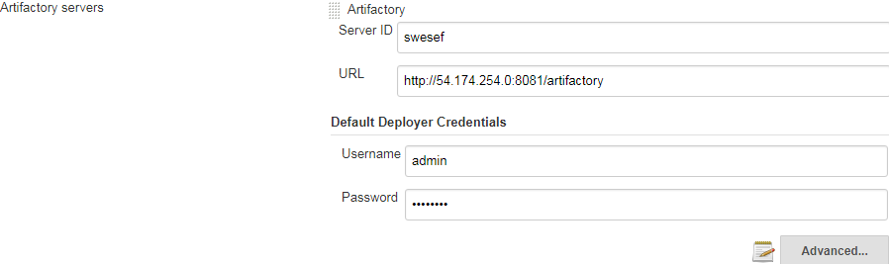

1. In build environment select ant/ivy Artifactory plugin option and enter the details as below

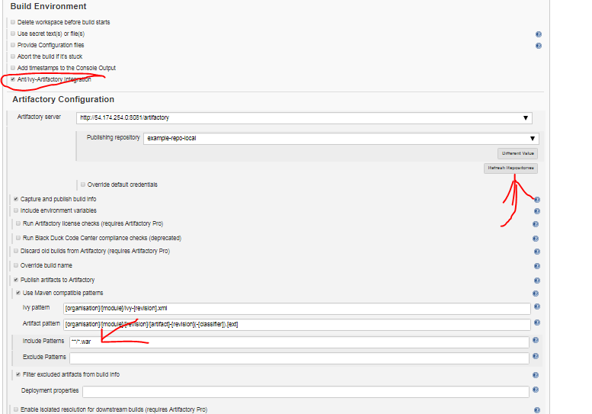

Just click on referesh repositories all data will come

At the bottom add **/*.war

Click on apply and save

1. Now run the build option

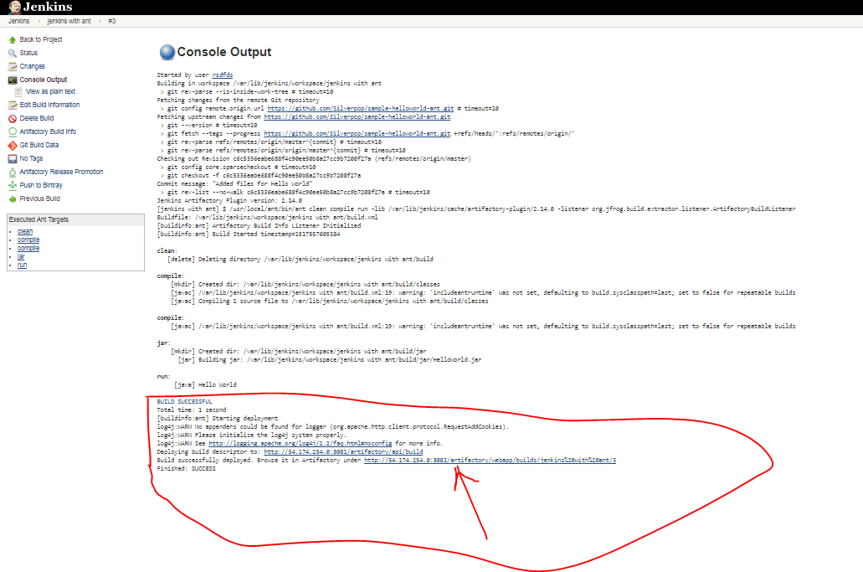

Our jar file is stored in jfog

Thanks guys